Add a subsite:

Click Setting

Site Contents

Select New Subsite and select Project Site

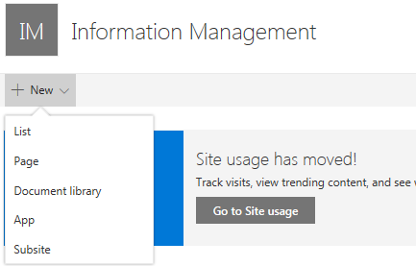

Edit Links

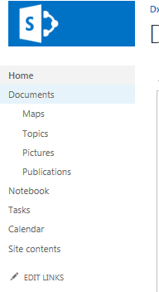

Click Settings, Edit Page, click Add Web Part

Select the web part and pick orientation on page “Add part to”

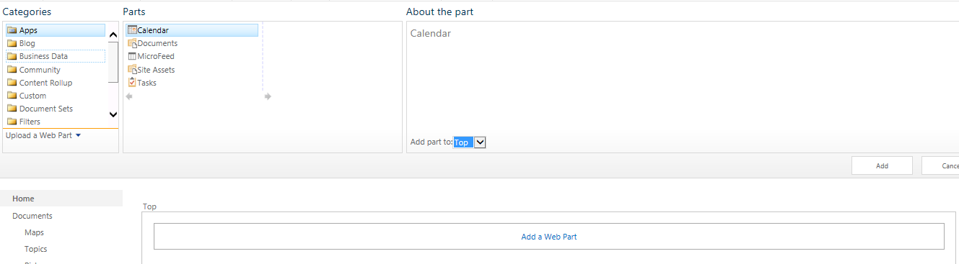

Create document libraries and link them:

Click Setting

Site Contents

Select New Document Library

Copy link rom Document library

Edit links on side bar and enter URL

# Create Knowledge Base page

**Create a subsite**

**Create page**

**Add Search webparts**

**Edit Search Results**

**Change Query**

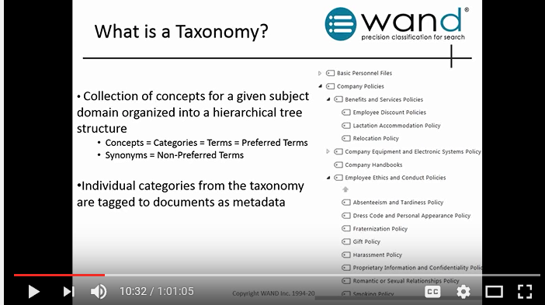

# Taxonomy

Site Settings

Term Store

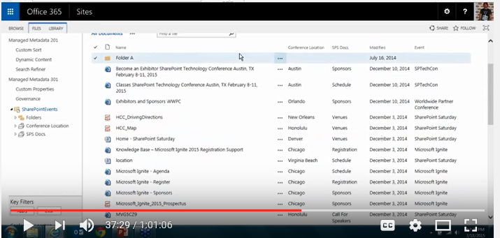

Insert Metadata column using this view:

Must setup column in Library settings

